Lab 16 Response: Evaluating Light and Noise Pollution

Part 1: Describing and Assessing Light Pollution
- Define light pollution—you may quote from your source. Provide a complete citation for your source.

- What strategies can be implemented to reduce light pollution in urban and rural areas? Provide complete citation(s) for the source(s) you used.

- Describe the appearance on the map of the areas that had significant amounts of artificial light. Where were some of the darkest night skies on Earth?

Table 16.1. Night sky and light pollution observations.
Date | Time | Location | Light level (units) | Sky Type¹ (description based on Bortle scale) | Light Pollution Sources
¹ refer to Figure 3 for descriptions
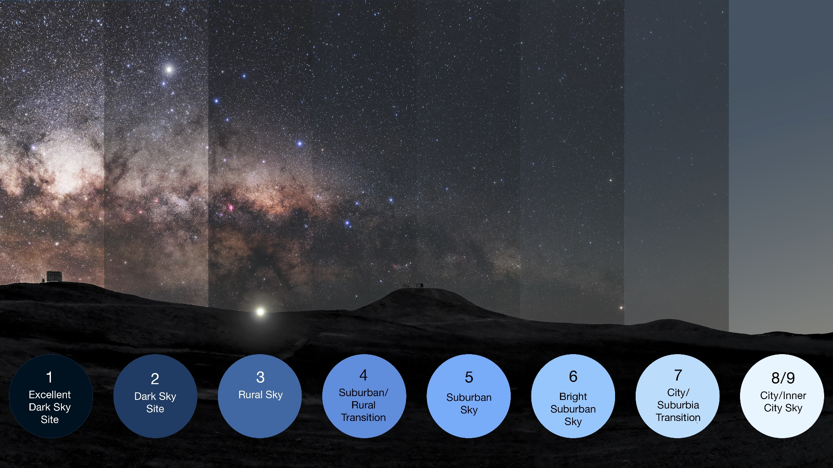
Figure 16.3: A representation of the Bortle scale, used to indicate the brightness of the night sky due to light pollution. Source: European Space Observatory. Credit: Credit: ESO/P. Horálek, M. Wallner. CC BY 4.0

- Discuss the sources of light pollution you identified.

- How did your results compare to those of your classmates? Explain similarities and differences.

- How did your results compare to the light pollution mapped for your region on Dark Sky Meter? (Use relative comparisons if unit measurements differ between the app’s output and the dark sky meter map.)

- Infer how the amount of light pollution affects the local ecosystem (e.g., plant growth, nocturnal animals, insect activity) and human health. Provide complete citations for the sources you used.

- Describe potential solutions to reduce light pollution in your observation area. Provide complete citation(s) for the source(s) you used.

Part 2: Light Pollution and Birds
- Describe the connection between light pollution and migrating birds: What happens and why? What structures are involved? How significant is the issue? Describe some solutions to reduce the problem.

- Why does the bird tracking data on BirdCast feature nocturnal migration? Cite the source(s) used for your response.

- Provide a screenshot of peak bird movement for one of the days you evaluated. Describe the terrain and landcover (vegetation, water, urban or rural characteristics) of the area you chose. Explain landscape features that might help the birds to navigate and structures that may cause them harm and why. Correlate this to observations on light pollution that you made in Part 1 of this lab.

- Describe the weather in area during the time you tracked migration. Was the weather a potential factor affecting bird movement? How might the weather interact with other hazards you identified in question 3? Explain.

Part 3: Describing and Assessing Noise Pollution

Table 16.2a: Noise pollution data collection for location 1 (describe where):
Date, weather¹ | Time² | Distance from Noise Source³ | Noise level (dB) | Noise Pollution Source/s
Baseline,0 min
Time:
 | 10 min
 | 20 min
 | 30 min
Baseline, 0 min
Time:
 | 10 min
 | 20 min
 | 30 min
¹ Choose a day with fair weather; note if windy.
² Begin when background noise is occurring, but no major noise source is active. Record your actual time of day using AM/PM or 24-hr time.
³ Give approximate distance from source (e.g., 5 m, 20 m) and be consistent across all measurements. Baseline measurement will be the close distance from source taken at start of monitoring (time = 0 min). Your instructor may require you to submit screenshots of your application’s output along with this table.

Table 16.2b: Noise pollution data collection for location 2 (describe where):
Date, weather¹ | Time² | Distance from Noise Source³ | Noise level (dB) | Noise Pollution Source/s
Baseline,0 min
Time:
 | 10 min
 | 20 min
 | 30 min
Baseline, 0 min
Time:
 | 10 min
 | 20 min
 | 30 min
¹ Choose a day with fair weather; note if windy.
² Begin collecting baseline data when background noise is occurring, but no major noise source is active. Record your actual time of day using AM/PM or 24-hr time.
³ Give approximate distance from source (e.g., 5 m, 20 m) and be consistent across all measurements. Baseline measurement will be the closest distance from source. Your instructor may require you to submit screenshots of your application’s output along with this table.

Part 3 Questions
- (a) Calculate the average noise level at each location. Show your work.
(b) Compare the differences in average noise between these relatively noisy and quiet areas.

- Graph the noise level against the time of day for each location to visualize patterns in noise pollution over time. Consult your instructor and group members to efficiently show your data in one or two graphs. Insert your graph(s):

- (a) Which sources contribute most to noise pollution at each site? How did they vary at different times?
(b) Compare your results to those of your classmates. Explain similarities and differences.

- What are the potential health impacts of the noise levels you measured for both humans and wildlife? Include consideration of maximum levels. For example, prolonged exposure to sounds over 85 dB can cause hearing damage in humans.

- How does noise pollution affect wildlife behavior, including communication, mating, and feeding patterns?

- What strategies could be implemented to reduce noise pollution at your study sites? In urban areas in general?

