# Lab 18 Response: Investigating Salt Pollution

## Hypothesis

State your hypothesis regarding the effect you expect salt to have on radish seed germination:

Briefly explain the reasoning/prior knowledge that led you to propose this hypothesis:

## Photos

To receive credit for tables and figures, upload TWO photos of your experimental setup as follows:

* Photo of experimental setup on the first day—DAY 1
* Photo of experimental setup on the last day—DAY 7

Make sure all 5 seed germination trays are labeled and clearly visible in each photo.

## Data Tables

**Table 18.1. Counts of radish seeds germinating over time according to salt treatment.**

|  |  |  |  |  |  |  |
| --- | --- | --- | --- | --- | --- | --- |
| Day of Exper-iment | Seeds germinating in **CONTROL** | Seeds germinating in **VERY LOW SALT CONCENTR-ATION** | Seeds germinating in **LOW SALT CONCENTR-ATION** | Seeds germinating in **MEDIUM SALT CONCENTR-ATION** | Seeds germinating in **HIGH SALT CONCENTR-ATION** | Additional Observations |
| 1 |  |  |  |  |  |  |
| 2 |  |  |  |  |  |  |
| 3 |  |  |  |  |  |  |
| 4 |  |  |  |  |  |  |
| 5 |  |  |  |  |  |  |
| 6 |  |  |  |  |  |  |
| 7 |  |  |  |  |  |  |

**Table 18.2. Percentage germination of radish seeds over time according to salt treatment.**

|  |  |  |  |  |  |
| --- | --- | --- | --- | --- | --- |
| Day of Experiment | % germination in **CONTROL** | % germination in **VERY LOW SALT CONCENTRATION** | % germination in **LOW SALT CONCENTRATION** | % germination in **MEDIUM SALT CONCENTRATION** | % germination in **HIGH SALT CONCENTRATION** |
| 1 |  |  |  |  |  |
| 2 |  |  |  |  |  |
| 3 |  |  |  |  |  |
| 4 |  |  |  |  |  |
| 5 |  |  |  |  |  |
| 6 |  |  |  |  |  |
| 7 |  |  |  |  |  |

## Graphs

For **Figure 18.2**, plot the data from **Table 18.1**.

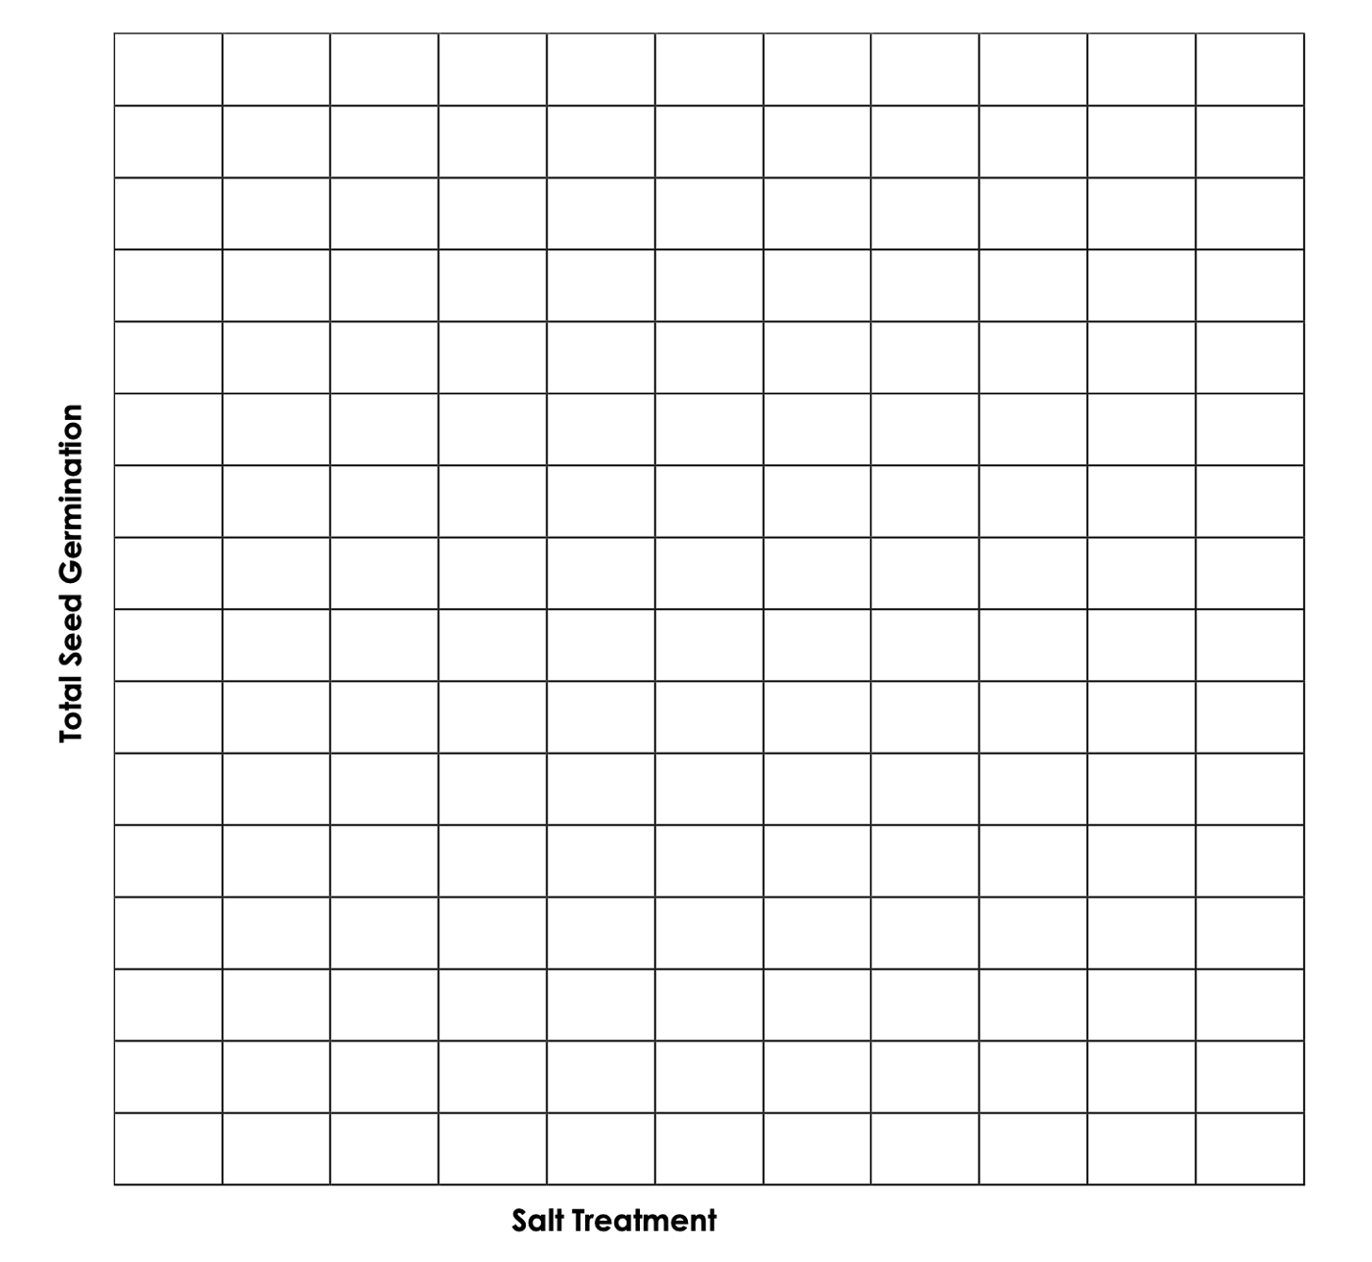

**Figure 18.2:** Total seed germination for radish seeds based on exposure to salt pollution

Brief interpretation of **Figure 18.2:**

For **Figure 18.3**, plot the data from **Table 18.2**.

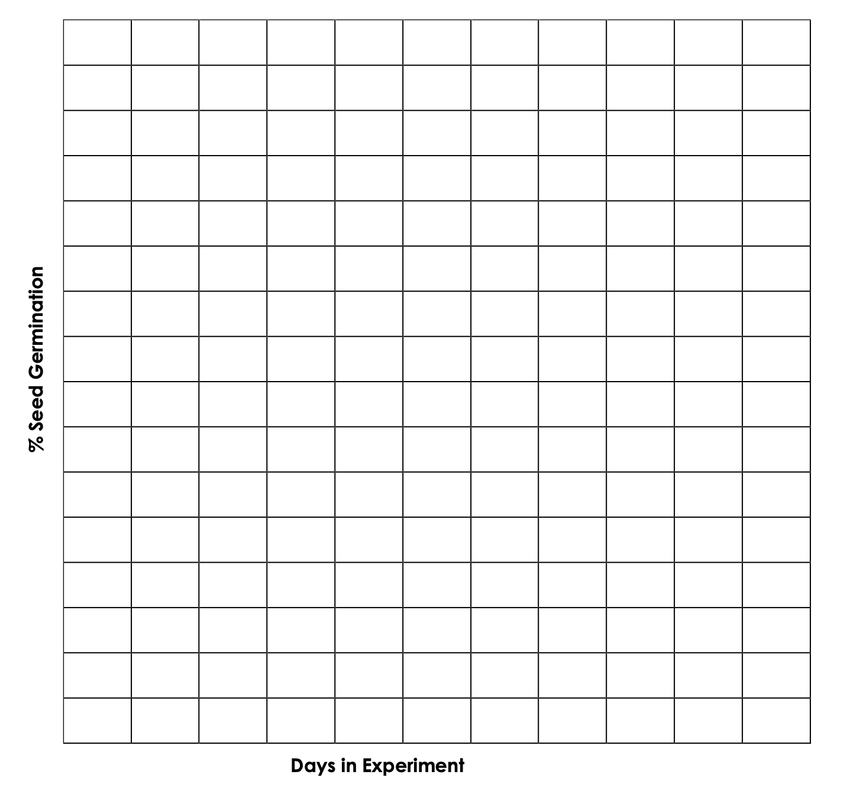

**Figure 18.3:** Percent radish seed germination over days of the experiment

Brief interpretation of **Figure 18.3**:

## Questions

1. Was your hypothesis supported? Explain using your data.
2. Describe what a limiting factor is, and what is meant by the range of tolerance. Relate your experimental findings to these two concepts.
3. What are some impacts of salt pollution on ecosystems? Discuss at least two impacts.
4. Connect salt pollution to our daily lives:
   1. What are some ways in which we contribute to salt pollution either directly or indirectly? Identify and discuss at least two ways.
   2. Discuss some solutions for how to reduce salt pollution.