# Lab 3 Response: Survival of the Fitter

## Data Tables

**Table 3.1. Fill in data for each of the six generations of simulation 1.**

**Predator Variant: FORK**

|  |  |  |  |  |  |  |  |  |
| --- | --- | --- | --- | --- | --- | --- | --- | --- |
|  | GEN 1 | % | Survivors | Reproduction | GEN 2 | % | Survivors | Reproduction |
| Garbanzo | 50 | 33.3% |  |  |  |  |  |  |
| Pinto | 50 | 33.3% |  |  |  |  |  |  |
| Lentil | 50 | 33.3% |  |  |  |  |  |  |
| TOTALS | 150 | 100% |  |  |  | 100% |  |  |

|  |  |  |  |  |  |  |  |  |
| --- | --- | --- | --- | --- | --- | --- | --- | --- |
|  | GEN 3 | % | Survivors | Reproduction | GEN 4 | % | Survivors | Reproduction |
| Garbanzo |  |  |  |  |  |  |  |  |
| Pinto |  |  |  |  |  |  |  |  |
| Lentil |  |  |  |  |  |  |  |  |
| TOTALS |  | 100% |  |  |  | 100% |  |  |

|  |  |  |  |  |  |  |
| --- | --- | --- | --- | --- | --- | --- |
|  | GEN 5 | % | Survivors | Reproduction | GEN 6 | Survivors |
| Garbanzo |  |  |  |  |  |  |
| Pinto |  |  |  |  |  |  |
| Lentil |  |  |  |  |  |  |
| TOTALS |  | 100% |  |  |  |  |

**Table 3.2. Fill in data for each of the six generations of simulation 2.**

**Predator Variant: KNIFE**

|  |  |  |  |  |  |  |  |  |
| --- | --- | --- | --- | --- | --- | --- | --- | --- |
|  | GEN 1 | % | Survivors | Reproduction | GEN 2 | % | Survivors | Reproduction |
| Garbanzo | 50 | 33.3% |  |  |  |  |  |  |
| Pinto | 50 | 33.3% |  |  |  |  |  |  |
| Lentil | 50 | 33.3% |  |  |  |  |  |  |
| TOTALS | 150 | 100% |  |  |  | 100% |  |  |

|  |  |  |  |  |  |  |  |  |
| --- | --- | --- | --- | --- | --- | --- | --- | --- |
|  | GEN 3 | % | Survivors | Reproduction | GEN 4 | % | Survivors | Reproduction |
| Garbanzo |  |  |  |  |  |  |  |  |
| Pinto |  |  |  |  |  |  |  |  |
| Lentil |  |  |  |  |  |  |  |  |
| TOTALS |  | 100% |  |  |  | 100% |  |  |

|  |  |  |  |  |  |  |
| --- | --- | --- | --- | --- | --- | --- |
|  | GEN 5 | % | Survivors | Reproduction | GEN 6 | Survivors |
| Garbanzo |  |  |  |  |  |  |
| Pinto |  |  |  |  |  |  |
| Lentil |  |  |  |  |  |  |
| TOTALS |  | 100% |  |  |  |  |

## Graphs

For **Figure 3.2**, plot the data from **Table 3.1**.

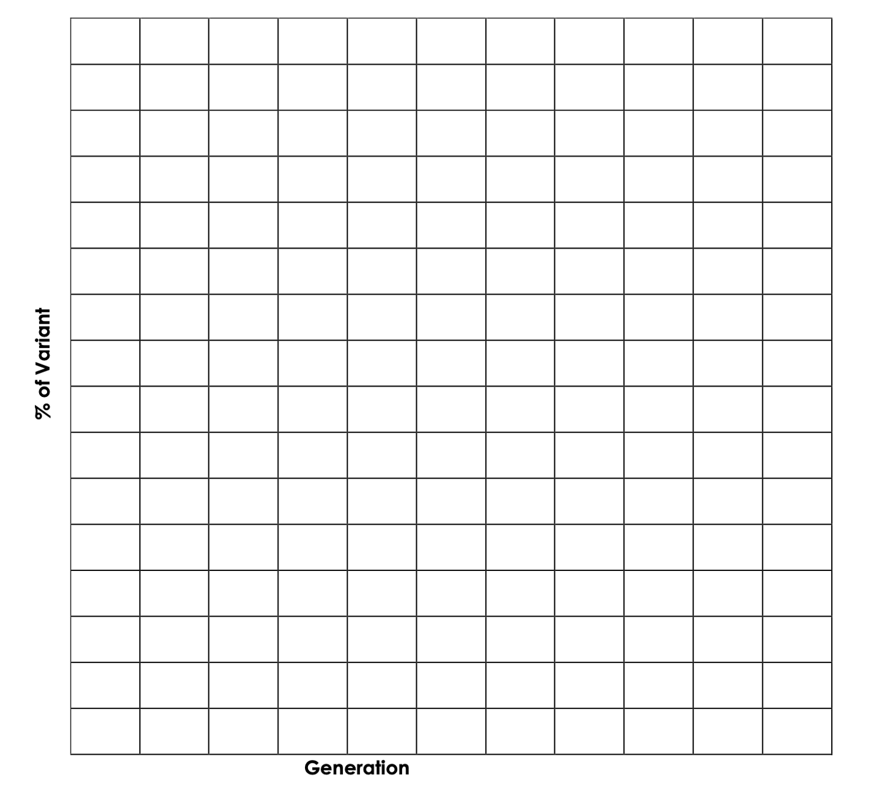**Figure 3.2:** Changes in bean variant percentage over 6 generations with FORK predator

Brief interpretation of **Figure 3.2**:

For **Figure 3.3**, plot the data from **Table 3.2**.

**Figure 3.3:** Changes in bean variant percentage over 6 generations with KNIFE predator

Brief interpretation of **Figure 3.3**:

## Questions

1. Respond to this question based on the predator–prey simulation using the FORK predator:

The Beanus (prey) population started with an equal number of individuals of each variant (garbanzo, lentil, and pinto). How did this change over the course of the experiment?

* 1. Which variant(s) became more common in the total population? Explain why.
  2. Which variant(s) became less common in the total population or were eliminated? Explain why.
  3. Did any variant remain about the same in the total population? Explain why.

1. Respond to this question based on the predator-prey simulation using the KNIFE predator:

The Beanus (prey) population started with an equal number of individuals of each variant (garbanzo, lentil, and pinto). How did this change over the course of the experiment?

* 1. Which variant(s) became more common in the total population? Explain why.
  2. Which variant(s) became less common in the total population or were eliminated? Explain why.
  3. Did any variant remain about the same in the total population? Explain why.

1. What is meant by “survival of the fitter” and why is it more appropriate to say “survival of the fitter” rather than “survival of the fittest”? Explain how this concept is demonstrated in this lab.
2. How do the results of your lab simulation(s) of predator–prey evolution apply to natural predator and prey populations?

To answer this question:

* 1. Explain how predator and prey populations adapt in response to each other (i.e., how the predator–prey interaction acts as the selection agent). Provide an example from natural predator and prey populations as part of your discussion.
  2. What is this particular evolutionary pattern called?

1. Aside from biotic factors such as predator–prey interactions, abiotic factors also operate as selection agents on species. Identify two abiotic factors and provide examples from natural populations to illustrate how these factors have operated as agents of natural selection.
2. Humans, as a biotic component of the ecosphere, have acted in many ways to directly or indirectly function as a selection agent for other species. Describe two specific examples of how human activities have operated as agents of selection on plant and animal species.