# Lab 12: Investigating Evolutionary Relationships with BLAST Response Form

## Part 1. Interpret phylogenetic tree diagrams

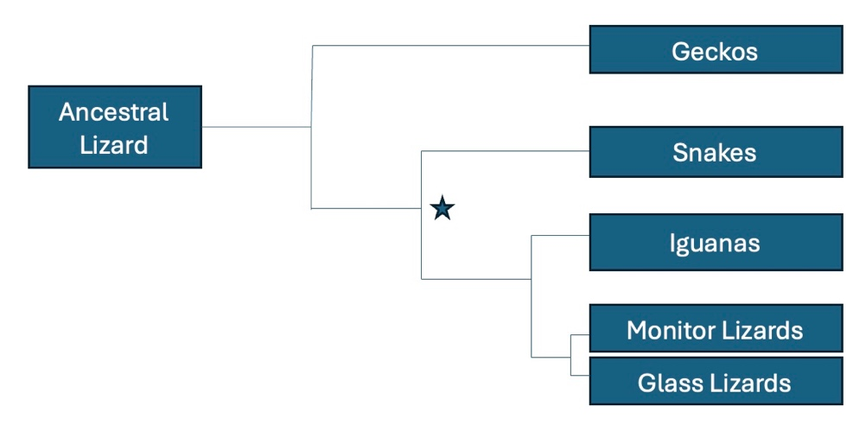**Figure 12.1:** Phylogenetic tree illustrating relationships among geckos, snakes, iguanas, monitor lizards, and glass lizards

1. In a complete sentence, describe what the branch points and lines in a phylogenetic tree represent.
2. List all modern descendants of the organism that was alive at the point indicated by the asterisk.
3. According to the tree above, what animal is most closely related to the ancestral lizard?
4. Which are more closely related, the snakes and glass lizards or the iguanas and glass lizards? Explain your reasoning.
5. Circle the point on the tree that represents the most recent common ancestor of iguanas and monitor lizards.

## Part 2. Compare DNA samples across multiple lineages to establish homology

1. What is the total number of base pairs included in the sequence to be analyzed in **Table 12.1**?
2. Count the number of nucleotides that are like the ancestral sequence, then enter the number in the numeration table for each species pair.

**Table 12.2. Numeration table to write the number of similar bases between each species.**

|  |  |  |  |  |  |
| --- | --- | --- | --- | --- | --- |
|  | Ancestral | Species 1 | Species 2 | Species 3 | Species 4 |
| Ancestral | x |  |  |  |  |
| Species 1 |  | x |  |  |  |
| Species 2 |  |  | x |  |  |
| Species 3 |  |  |  | x |  |
| Species 4 |  |  |  |  | x |

1. Develop a phylogenetic tree hypothesis based on the relationships among these organisms and then draw it in the space below.

1. How many of the total number of base pairs do not align with the ancestral species?
   1. Species 1 ______
   2. Species 2 ______
   3. Species 3 ______
   4. Species 4 ______
2. Convert the number of noncomplementary pairs into a percentage of the total base pairs. This is called the sequence divergence. Write the sequence divergence from the ancestral sequence for each species below.
   1. Species 1 ______
   2. Species 2 ______
   3. Species 3 ______
   4. Species 4 ______
3. Place the species in order from most to least homologous compared to the ancestral species.



1. Based on the evidence, which species is most closely related to the ancestral species?
2. Describe how DNA sequence divergence provides scientists with information about relatedness.
3. Fill in the phylogenetic tree in **Figure 12.2** with species 1 through 4 to summarize the relatedness of the organisms that supplied the samples.

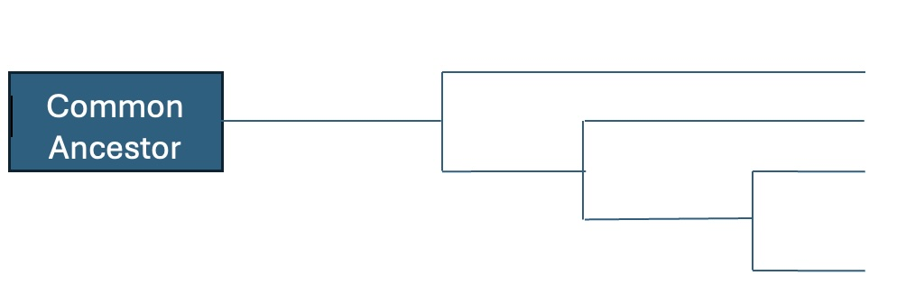

**Figure 12.2:** Phylogenetic tree hypothesis illustrating relatedness among five hypothetical species based on numeration **Table 12.2**

## Part 3. Compare Cytochrome c amino acid sequence using the NCBI database

BLAST results:

|  |  |  |  |
| --- | --- | --- | --- |
| Species | Percent identify | Alignment Score | E-value |
|  |  |  |  |
|  |  |  |  |
|  |  |  |  |
|  |  |  |  |
|  |  |  |  |
|  |  |  |  |
|  |  |  |  |

1. Comparison of percent identity values for all species to the human query sequence.
2. Species Ranking: rank the species from most to least like humans.

1. Phylogenetic Tree Drawing
2. How many different species are represented in the cytochrome c sequences that appear?
3. What do the individual letters in each alignment sequence represent?
4. Considering the morphology (physical form) and ecology of each species in the list, make a prediction about the most unrelated species. Circle the species you think would have the **least** amount of DNA overlap for each example. Discuss the rationale for your decisions as a group.
   * 1. Circle one: is a chicken or rhesus monkey **least** related to a pig?
     2. Circle one: is a human or tuna **least** related to a whale?
     3. Circle one: is a fly or chicken **least** related to a tuna?
5. Using the data presented in the alignment table, complete **Table 12.4** below by writing down the number of differences between the cytochrome c amino acid sequence in a human and each of the indicated species.

**Table 12.4: Comparison of the number of amino acid mutations between humans and the whale, rhesus monkey, chicken, pig, yeast, fly, and tuna**

|  |  |
| --- | --- |
| Species common name | # of mutated amino acids compared to human |
| Whale |  |
| Rhesus monkey |  |
| Chicken |  |
| Pig |  |
| Yeast |  |
| Fly |  |
| Tuna |  |

1. Which of the organisms in the table is the closest relative of humans based on the number of mutated amino acids?
2. Which of the organisms in the table is the most distant relative of humans?
3. Draw a phylogenetic tree to illustrate a phylogenetic relationship between the organisms in the table and humans, as suggested by the cytochrome c data.
4. How does your prediction about relatedness based on morphology and ecology compare to the relatedness gleaned from the phylogenetic tree developed using the cytochrome c amino acid sequence? Click “Phylogenetic Tree” in the left corner of the COBALT page to check the accuracy of your hypothesis.
5. Paste a screenshot of the COBALT phylogenetic tree. Highlight or circle all the mammals in the phylogenetic tree produced by COBALT.

1. How does the tree illustrate that all the mammals you circled belong to the same taxonomic class?
2. Compare the differences in amino acid sequences among the mammals with differences in other animal classes, e.g., Insecta (fly), Aves (chicken), Saccharomycetes (yeast), and Actinopterygii (tuna). Is there a noticeable pattern?

1. Is it valid for scientists to infer evolutionary relationships from a single protein? Justify your answer.
2. Which species are more closely related to humans?
3. What does the sequence similarity suggest about the divergence times of these species?
4. Create a simple phylogenetic tree based on the BLAST results, illustrating the evolutionary relationships among the species.