# Lab 15: Soil Ecology Response Form

1. Determine the type of soil in each sample using table 15.1 and figure 15.1, then answer questions 1-4.

**Table 15.1: Soil texture height measurements using the jar test separation method**

|  |  |
| --- | --- |
| Measurements | Value (cm) |
| Height of sand layer |  |
| Height of silt layer |  |
| Height of clay layer |  |
| Total height of layers |  |
| % Sand | (sand height / total height) × 100 = |
| % Silt | (silt height / total height) × 100 = |
| % Clay | (clay height / total height) × 100 = |

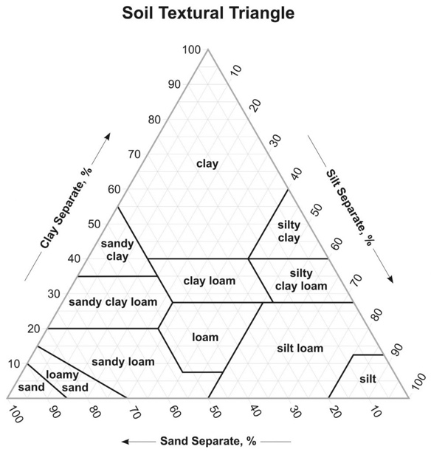

**Figure 15.1:** Soil texture triangle depicting clay, silt, and sand as a percentage of the total amount of soil

### Questions

1. Using the soil texture triangle, identify the soil type with the greatest soil retention ability and water percolation rate.
2. Identify the texture of your soil sample.
3. What inferences can you make about how plants will grow in each soil sample you collected?
4. Some neighbors get angry when people walk on their lawn, and businesses sometimes discourage people from walking in areas that are not a designated path. What are some reasons people might discourage people from trampling their turf?

## Part A. Investigating the relationship between natural soil salinity/conductivity and pH and seed germination rate

1. Prediction #1:
2. Prediction #2:
3. Complete table 15.2

**Table 15.2: Soil pH and conductivity measurements for soil slurry samples 1-3 and the control**

|  |  |  |
| --- | --- | --- |
| Soil Sample | pH | Conductivity (mS/cm) |
| Sample 1 |  |  |
| Sample 2 |  |  |
| Sample 3 |  |  |
| Control |  |  |

1. Complete table 15.4.

**Table 15.4. Number of seeds germinated by day over a seven-day period.**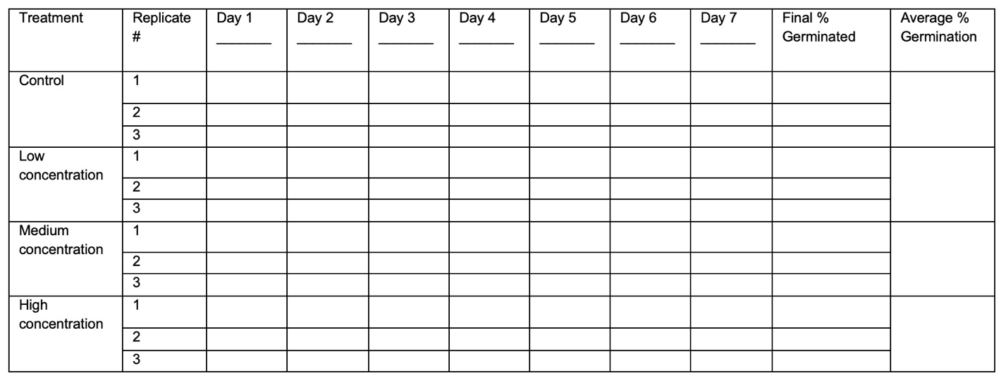

1. Graph the average percent germination data.  
     
     
     
   
2. Is there a correlation between the conductivity and pH of the soil and the rate of seed germination?

## Part B. Investigating Soil Biology

1. Complete table 15.3

**Table 15.3. Stepwise table for calculating the Shannon Wiener Index of biodiversity.**

|  |  |  |  |  |
| --- | --- | --- | --- | --- |
| Column 1 | Column 2 | Column 3 | Column 4 | Column 5 |
| Species | Frequency | **p**i | Ln (**p**i) | **p**i * ln (**p**i) |
|  |  |  |  |  |
|  |  |  |  |  |
|  |  |  |  |  |
|  |  |  |  |  |
|  |  |  |  |  |
|  |  |  |  |  |
|  |  |  |  | H = |

### Questions

1. Compare the communities of organisms found at each site sampled. How do they differ in abundance and diversity?
2. What conclusions would you draw about the amount of nutrients in the soil samples, based upon the relative abundance of biota found there?
3. How might the composition of biodiversity affect the rate of leaf and debris decomposition?
4. There are many ways your experimental setup could have affected your results. Remember, most of these invertebrates are small with limited mobility. What might you have found if you instead used a smaller amount of soil? A different watt lightbulb? How could you redesign your apparatus to collect a less biased sample?

## Alternate Procedure for Online Courses: Investigating the effect of salinity, pH, and lipids on radish seed germination.

1. Write your hypothesis:
2. Completetable 15.4.

**Table 15.4. Number of seeds germinated by day over a seven-day period.**



1. Graph the average percent germination data.



### Questions

1. Identify the independent variable in this study.
2. What was your total sample size?
3. Did you reject or fail to reject your hypothesis?
4. Reflect on the effect of the type of pollution you investigated on seed germination rate. What is the real-world application?
5. Name one factor that could lead to errors in your dataset.
6. The optimum soil pH range for most plants is 6.0 to 7.0. What inference can you make about the quality of soil you collected in your sample based on the pH measured?
7. Why is pH an important aspect of soil fertility?
8. Nitrogen pollution from burning fossil fuels causes excess nitrogen deposition into soils in the form of HNO3. What is the potential impact of HNO3 deposition in soils?
9. Consider the impact of lawncare services that enhance the soil with products that change its pH, conductivity, or other parameters. Select one and discuss the potential impact it has on soil ecology.