# Lab 17: Aquatic Ecology

## Purpose

To investigate the diversity of microscopic pond organisms and understand potential food chains.

## Learning Objectives

At the conclusion of this exercise, students should be able to:

* Identify some common pond organisms and describe their feeding niches.
* Compare trophic levels in a community.
* Construct food chain and food web diagrams.

## Why It’s Relevant

Much of the diversity of wetland communities exists at the microscopic level. The miniscule bacteria, protists, and animals help make energy available to support higher trophic levels, such as fish, amphibians, turtles, waterfowl, and aquatic mammals. Knowledge of the interactions of all of these species is crucial for understanding how to keep aquatic ecosystems healthy, both for their ecological value and for human recreational activities such as hunting, fishing, and personal enjoyment.

## Introduction

Among the main items of interest for ecologists is the flow of energy through a biological community. Plants and a variety of other photosynthesizing organisms convert kinetic solar energy into potential energy in the form of carbohydrates in their bodies. These are then fed on by heterotrophic organisms, which convert the stored energy of plants into stored energy of their own biomolecules. These heterotrophs are in turn fed on by other heterotrophs, and so on. In this way, energy, originally from solar radiation, is passed through the community. Eventually, all energy stored in this way leaves the community as heat, and is no longer usable by living things to do anything productive.

Ecologists work to figure out the identities of the organisms passing energy within specific ecosystems. Which species of primary producers are converting solar energy into energy within carbohydrate molecules? How many are there and how much total energy does each species convert? Which heterotrophs are eating which producer organisms? Which heterotrophs are eating which other heterotrophs? This information helps scientists understand the roles each species is playing in the community, and therefore which species are important in maintaining the overall health of the community. Once ecologists identify sequences of organisms that are connected by feeding relationships, they may construct a food chain.

**Figure 17.1** is an example of a typical food chain. A food chain represents one potential pathway that energy might take on its way through a community. A food chain displays organisms at different trophic levels. The base of a food chain is always comprised of some organism capable of photosynthesis: a plant, an alga, or a photosynthetic bacterium. These organisms are collectively called primary producers. Heterotrophic organisms that feed directly on producers are referred to as primary consumers. Primary consumers are fed on by secondary consumers. These are fed on by tertiary consumers, which are in turn fed on by quaternary consumers (though these tend to be rare).

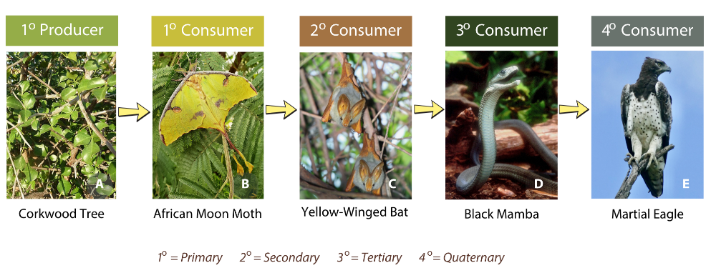**Figure 17.1:** A potential food chain in the African savanna biome

Food chains are a simple way to visualize potential paths that energy may take through a community. However, in reality, communities are much more complicated! First, there are always several paths that energy might take, as many different species may play the roles of producers and consumers. For example, a grass may be fed on by a deer or a bison or a rabbit. Second, organisms often act as multiple trophic levels over time. An omnivore like a bear may sometimes eat berries, thus acting as a primary consumer, and other times eat fish, acting as a secondary or tertiary consumer. To display the actual complexity of feeding relationships in a community, ecologists construct more complicated diagrams called food webs.

**Figure 17.2** displays an example of a food web. Note the overall complexity, and the variety of organisms connected by arrows. In a food web, arrows are always drawn from an organism being eaten to its eater, depicting the flow of energy. In **Figure 17.2**, notice that multiple consumers are gaining energy from individual species, and that consumers often act as multiple trophic levels.

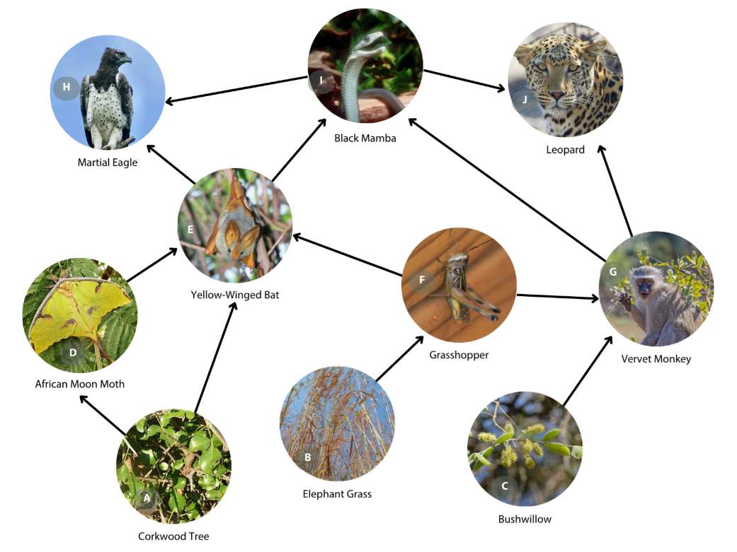**Figure 17.2:** A potential food web in the African savanna biome, with arrows pointing from an organism that is eaten to an organism that is gaining energy from it

The purpose of today’s lab is to sample the plankton community of one of the campus ponds to construct a potential food chain and food web for the area. The nature pond on campus is home to a diverse array of microscopic and macroscopic organisms. As you approach the pond today, do so slowly and quietly and you may observe some of the macroscopic animals found in the area. A partial list of these is found in **Table 17.1** below.

**Table 17.1. Partial list of macroscopic animals found in campus nature pond**

|  |  |
| --- | --- |
| **Animal** | **Major Group** |
| Coyote | Mammals |
| Raccoon | Mammals |
| Muskrat | Mammals |
| Short-tailed Shrew | Mammals |
| Red-winged Blackbird | Reptiles (birds) |
| Blue Heron | Reptiles (birds) |
| Belted Kingfisher | Reptiles (birds) |
| Wood Duck | Reptiles (birds) |
| Garter Snake | Reptiles |
| Painted Turtle | Reptiles |
| Snapping Turtle | Reptiles |
| Tiger Salamander (larva and adult) | Amphibians |
| Green Frog (larva and adult) | Amphibians |
| Bullfrog (larva and adult) | Amphibians |
| Bluegill | Fish |
| Fathead Minnow | Fish |
| Dragonfly (larva) | Insects |
| Water Boatmen | Insects |
| Diving Beetles | Insects |
| Rusty Crayfish | Crustaceans |
| Pond Snails | Mollusks |
| Freshwater Mussels | Mollusks |

## Procedure

Form small teams (3-4 students per team works best) and obtain a plankton net and at least two plastic sampling jars from the lab supply. A plankton net (**Figure 17.3**) has a mesh consisting of microscopically small holes with a collection bottle at the end of the net. When pulled through the water column, water molecules will escape the net, but most tiny organisms will not. Head out to the nature pond and select two sites along the pond for sampling (your instructor may have specific requirements for which locations you choose). Choose specific sites that have at least several inches of water depth and are free of floating or submerged vegetation that might get stuck in your net.

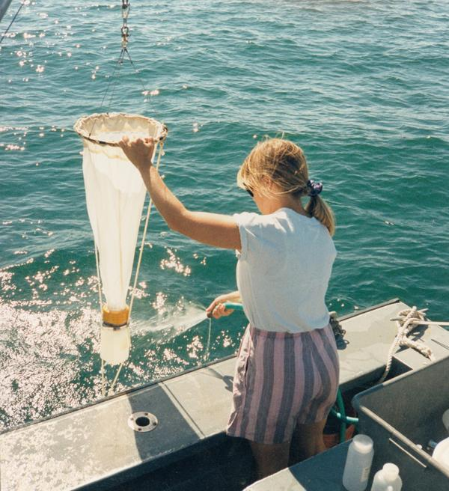

**Figure 17.3:** Plankton nets come in sizes ranging from small to large, but all have a mesh with microscopically small holes to trap microorganisms in the container at the net’s end

Microscopic organisms are found throughout the pond. The purpose of the plankton net is to concentrate them into your sample. Throw the plankton net at least 10 feet out into the pond from your sampling location. Then, slowly and steadily pull the net back towards you. Pull hard enough that the net stays suspended in the water column and does not drag along the pond bottom. Otherwise, you will spend a lot of time today cleaning your net! Repeat the throw and pull back to you at least six times in this first sampling location. When finished, pour the contents of the collection bottle at the end of your net into one of your sampling jars. Screw the lid on tightly and label it so that you remember which sample location it came from. Next, head to your second sampling location along the pond and repeat this process.

Return to the lab and prepare wet mounts of your samples by using an eye dropper to place 1-2 drops of fluid from the sampling jars onto a microscope slide. Focus on the sample at scanning power (40X total magnification) and search for organisms. Small animals and animal-like protists might be moving through the sample. Many algae are likely to be stationary. Do your best to identify any organism detected by using posters and field guides available in the lab, internet searches of common pond organisms, and your instructor. Microscopic pond life is so diverse that it will be extremely difficult to identify organisms to species, or even genus. Simply identifying them to major groups, such as “diatoms” or “rotifers” may be sufficient. **Write down any identifications you are able to make as an individual and then pool the results from all members of your group by writing the names of the organisms (or their major groups) into the first column of a table that you create**. Each team member should view at least two wet mounts from each of the sampling locations (a total of 4 slides prepared per team member).

For any organisms you were able to identify, do some quick research to learn about their feeding habits. Discover which are types of producers and which are consumers. **Add this information for each identified organism into the second column of the table**. **For the consumers, discover which other organisms they tend to eat and add this into the third column of the table.**

Next, each individual will use information from **Table 17.1** in the Background section and the group’s table of identified pond organisms to **create two images: one potential food chain and a food web** that describes the nature pond community. **For the food chain, choose organisms from the two tables that might plausibly representat least the first four trophic levels described in the Background section. Write the name of the organism and the trophic level in the chain. For the food web, choose a minimum of at least 12 organisms from the two tables to create a plausible food web for this community. In the web, label at least one organism for each of the first four trophic levels and label the trophic levels of at least two organisms that are acting on multiple trophic levels**. You will need to conduct research on some of the species in **Table 17.1** to discover what they prey on. Make sure that you are using microorganisms from your work on the pond sample as well as macroscopic organisms from **Table 17.1** in both cases! You will definitely not, however, need all organisms from both lists to complete this assignment.

## Alternate Procedure for Online Courses

Plankton nets have been used to collect four water samples from the College of DuPage campus nature pond using the methodology described in the Procedure section above. The species contained within each sample have been identified for you (to the best of the researcher’s abilities; note that some species are listed as #1 or #2 of a major group) and are listed in the [attached worksheet](https://cod.pressbooks.pub/app/uploads/sites/175/2025/05/Lab-17-Additional-Spreadsheet-pond-samples-species-list.xlsx) [.xls, 21 kb].

In a separate document, classify each identified species in all of the samples as either a producer or a consumer. For the consumers, figure out which other types of organisms they tend to prey on and add that information behind their name. Some quick internet research should suffice to find this information.

Once your classification and research are complete, the information from this as well as from Table 18.1 in the Background section will be used to **create two images: one potential food chain and a food web** that describes the nature pond community. **For the food chain, choose organisms from Table 17.1 and your document that might plausibly represent at least the first four trophic levels described in the Background section. Write the name of the organism and the trophic level in the chain. For the food web, choose a minimum of at least 12 organisms from Table 17.1 and your work to create a plausible food web for this community. In the web, label at least one organism for each of the first four trophic levels and label the trophic levels of at least two organisms that are acting on multiple trophic levels**. You will need to conduct some research on some of the species in **Table 17.1** to discover what they prey on. Make sure that you are using microorganisms from your work on the pond sample as well as macroscopic organisms from **Table 17.1** in both cases! You will definitely not, however, need all organisms from both lists to complete this assignment.

Finally, read the Background section of this lab carefully and answer the summary questions below. **Submit your answers to these questions, the document in which you classified species from the pond sample, and the two diagrams (food chain and food web) that you constructed.**

## Summary Questions

1. In a hypothetical forest community, mosses and ferns photosynthesize. Ferns are fed on by aphids and mice, aphids are eaten by wasps and mice, wasps are fed on by birds, mice and birds are fed on by snakes, and snakes, in turn, are fed on by cougars. For each of the organisms below, identify its trophic level(s).
   1. snakes:
   2. ferns:
   3. mice:
2. Imagine that you were assigned to compare the species diversity of microscopic organisms from two different locations in the same pond. Choose two locations and write a hypothesis for this possible study. Write a one-sentence justification below the hypothesis that explains your thinking.
3. Which major animal groups were the most common in your samples from the nature pond?
4. Choose three vertebrate animals from **Table 17.1** that interest you the most. For each, write their 2-part scientific name (correctly formatted), write an interesting fact about their behavior, and make a sketch of their appearance below, noting any key identifying characteristics.