# Lab 1: Scientific Thinking and Method Lab Response Form

## Name and Course Section:

## Curiosity and Inquiry

1. What previous knowledge or observations (from readings, personal experience, previous coursework, etc.) inspired your question?
2. What is the question that you wish to investigate?

## Formulating a Hypothesis

1. What is your hypothesis?
2. What are your predictions?

## Testing the Hypothesis: Designing an Experiment

1. Before your team designs an experiment, practice identifying the independent and dependent variables as well as the control and experimental groups in the scenario below:

A group of scientists perform an experiment to test the activity of a new enzyme at various levels of acidity (pH). They put a known amount of the enzyme in a test tube, set the pH to neutral, and then measure the enzyme activity. They then decrease the pH and re-measure the enzyme activity. They continue this process until they have several data points.

In this experiment, what is the:

* 1. Independent variable:
  2. Dependent variable:
  3. Control group:
  4. Experimental group:

1. Design an experiment to test your group’s hypothesis.
2. What are the independent and dependent variables? *Helpful tip: For time management, choose 1 independent variable and 1 dependent variable for your experiment. For example, room temperature (1 independent variable) affects the amount a person sweats (1 dependent variable) instead of room temperature (1 independent variable) affects the amount a person sweats and their heart rate (2 dependent variables).*
3. What is the control group?
4. What is the experimental group?
5. That said, what is the sample size of your control and experimental groups? How many subjects will be in each group? How will you choose your subjects? Will you include any replications?

## Testing the Hypothesis: Data Collection

1. Below is a data table to keep track of your data.

|  |  |  |  |  |
| --- | --- | --- | --- | --- |
|  |  |  |  |  |
|  |  |  |  |  |
|  |  |  |  |  |
|  |  |  |  |  |
|  |  |  |  |  |
|  |  |  |  |  |
|  |  |  |  |  |

## Interpreting the Data: Simple Statistical Analysis of Results

1. Using the data in **Table 1.1** below, answer the following questions:

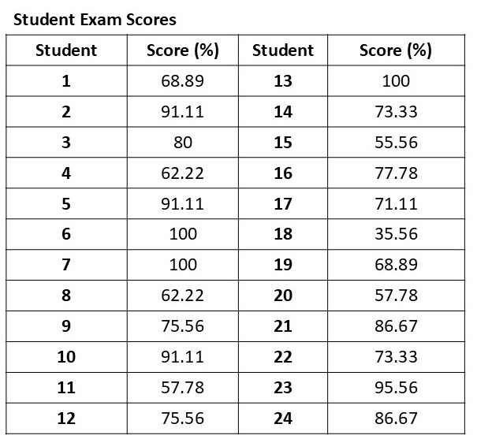

**Table 1.1. Student exam scores.**

1. What is the mean?
2. What is the mode?
3. What is the median?
4. What is the standard deviation?

## Visualizing the Data: Graphing and Understanding Relationships in Results

1. Now plot the data that your group collected below. Label the X and Y axes and choose the appropriate number scale for each axis. Refer to Appendix 1 for instructions on using Google Sheets to create graphs with standard deviation bars. *Helpful tip: Apply your knowledge about independent and dependent variables when labeling the axes.*



## Making a Conclusion

1. Do the results validate or reject your group’s hypothesis? Why or why not?
2. What is the group’s interpretation of the data and conclusions? Are there any resources or previous knowledge that support your team’s interpretation and conclusions?
3. What are some strengths of your experiment?
4. What are some weaknesses of your experiment?
5. Based on your weaknesses, how would you improve your experimental design?
6. What additional experiments might be done to confirm or refute your group’s conclusions?